A
Lab Records of
Web development Fundamental-html,css&javascript
Computer Science and Engineering- Sem 1

RUNGTA INTERNATIONAL SKILLS UNIVERSITY
SESSION: 2025-26

Submitted to- Submitted by-
Mr.Lakshman kumar sahu Name: SHIVAM KUMAR (Asst.Prof) Erp ID: RU-25-11367
SECTION-k

RUNGTA INTERNATIONAL SKILLS UNIVERSITY,CG
SCHOOL OF COMPUTER SCIENCE AND TECHNOLOGY

INDEX

S.NO | NAME OF PRACTICAL | SUBMISSION  DATE | REMARK
1. | Create +C46:C65a basic HTML web page using headings, paragraphs, and text formatting tags .
2. | Design a webpage demonstrating HTML links, images, and lists (ordered, unordered, nested) .
3. | Create a table-based layout with merged cells, alignment, and caption using HTML
4. | Design a webpage with an HTML form having text input, radio buttons, checkboxes, select menus, and submit/reset buttons .
5. | Use semantic elements (<article>,<section>,<nav>,<aside>,<footer>) to build a structured web page .
6. | Apply Inline, Internal, and External CSS styles to HTML elements.
7. | Style a web page using advanced CSS: Box Model, background images, borders, margins, and padding.
8. | Demonstrate the use of different CSS selectors (class, id, descendant, group, universal).
9. | Create a responsive web page using media queries and mobile-first design with flexible units.
10. | Use div and span elements for layout and apply styling with CSS.

Lab Record- 1.1
Q :- Create +C46:C65a basic HTML web page using headings, paragraphs, and text formatting tags .
Code :- 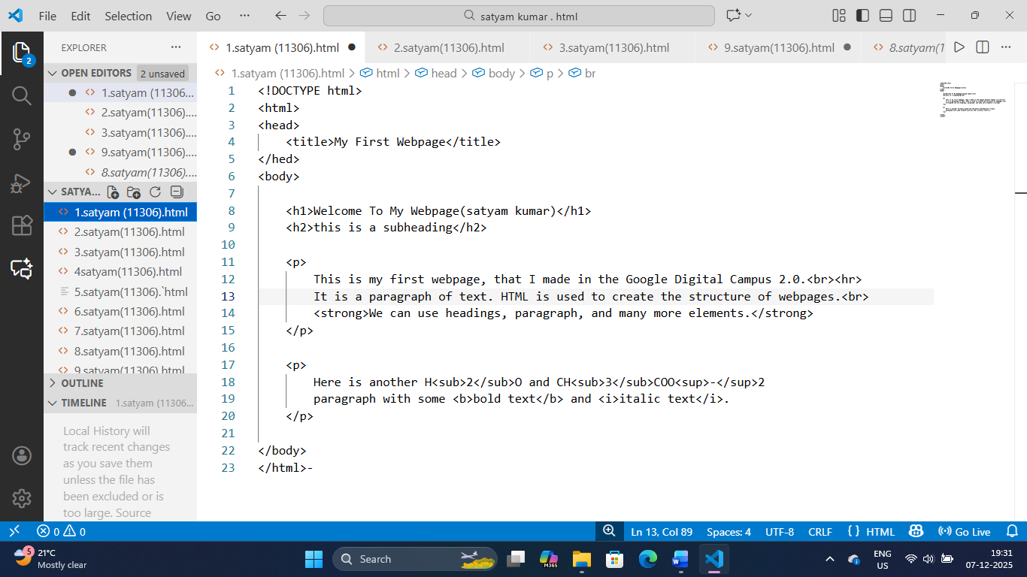

Output:-

Lab Record- 1.2
Q:- Design a webpage demonstrating HTML links, images, and lists (ordered, unordered, nested) .
Code:-
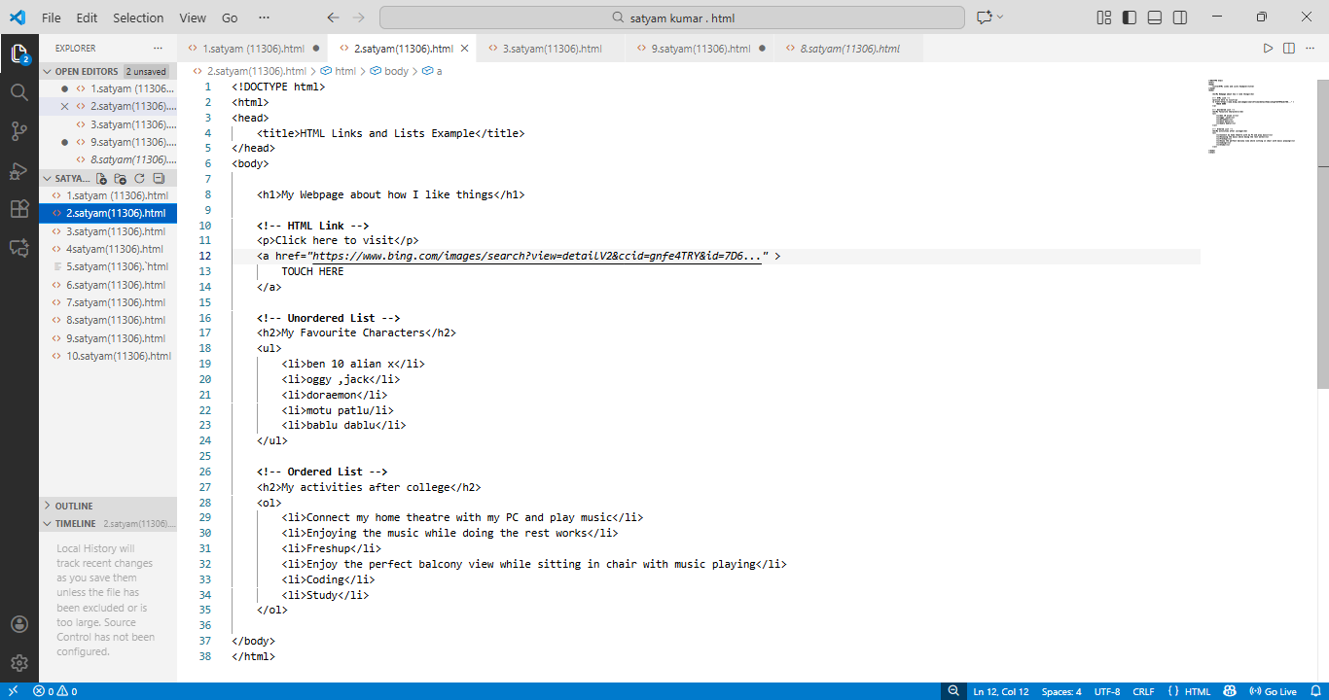

Output:-

Lab Record- 1.3
Q:- Create a table-based layout with merged cells, alignment, and caption using HTML.
Code:-

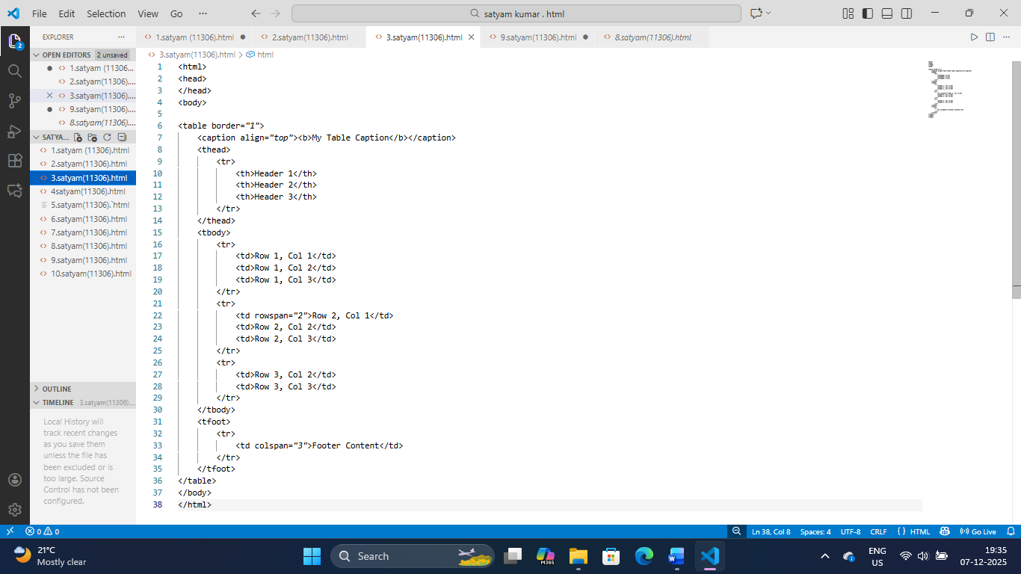
Output:-


Lab Record- 1.4
Q :- Design a webpage with an HTML form having text input, radio buttons, checkboxes, select menus, and submit/reset buttons.
Code:-
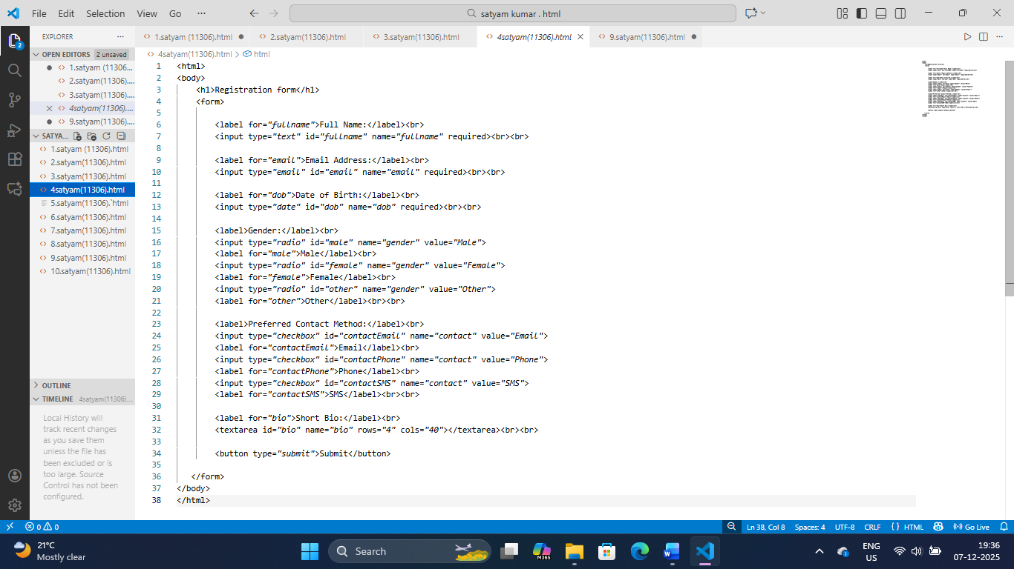
Output:-

Lab Record- 1.5
Q :- Use semantic elements (<article>,<section>,<nav>,<aside>,<footer>) to build a structured web page .
Code:-
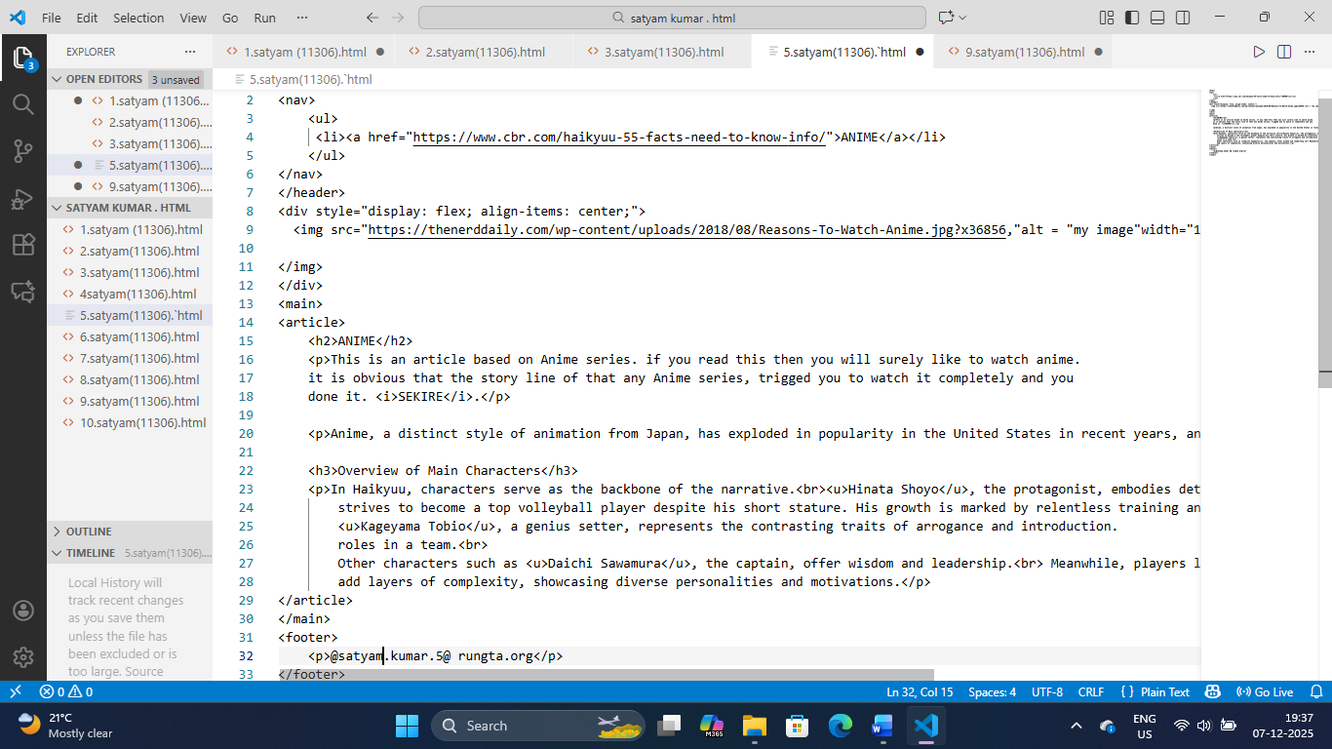
Output:-

Lab Record- 1.6
Q:- Apply Inline, Internal, and External CSS styles to HTML elements.
Code:-
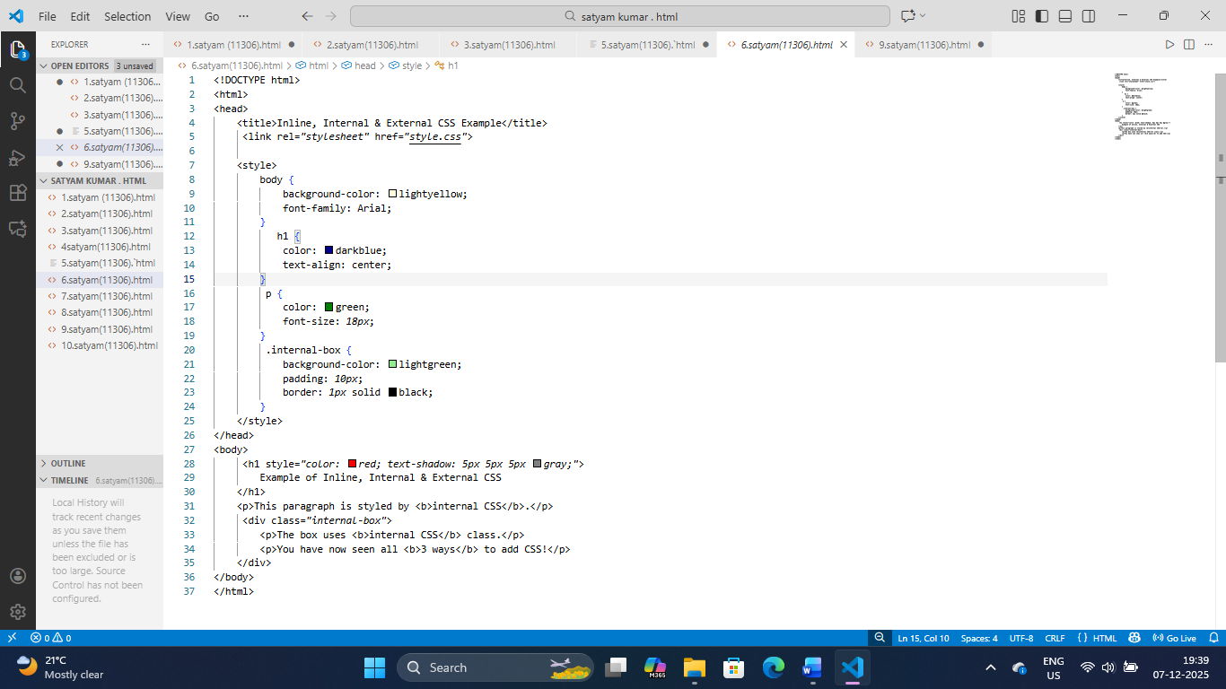
Output:-

Lab Record- 1.7
Q :- Style a web page using advanced CSS: Box Model, background images, borders, margins, and padding.
Code:-

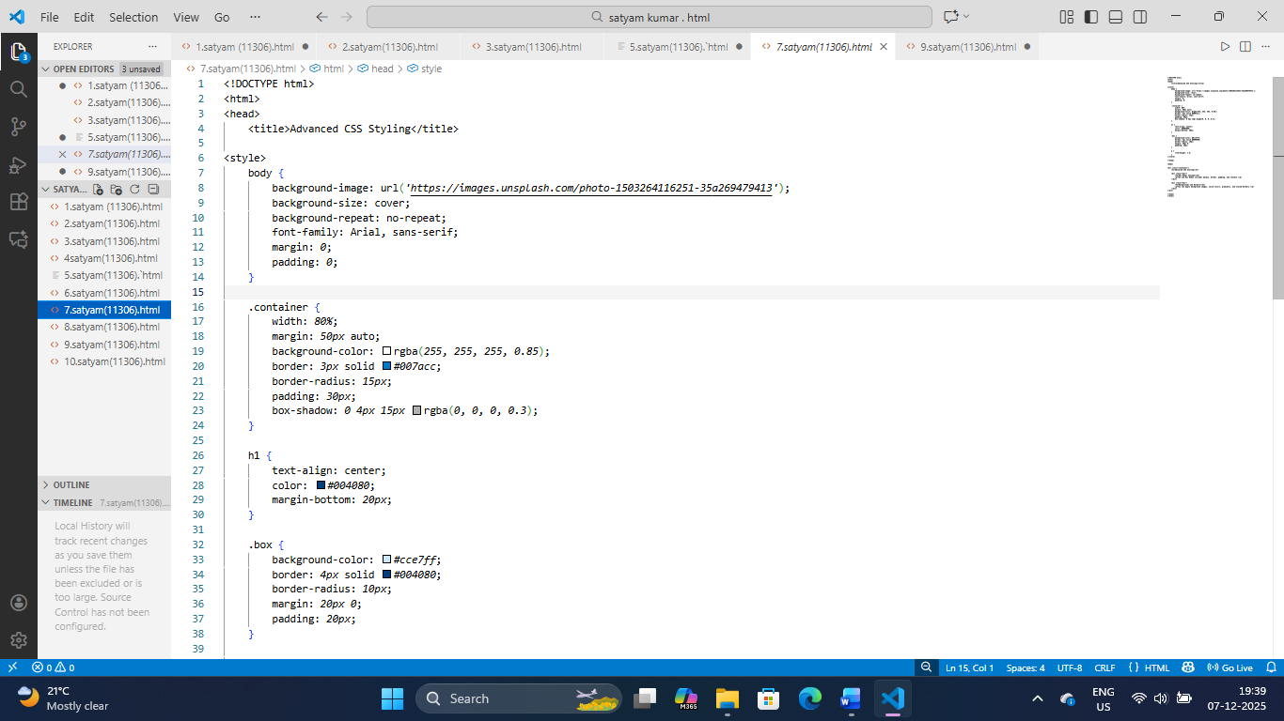
Output:-
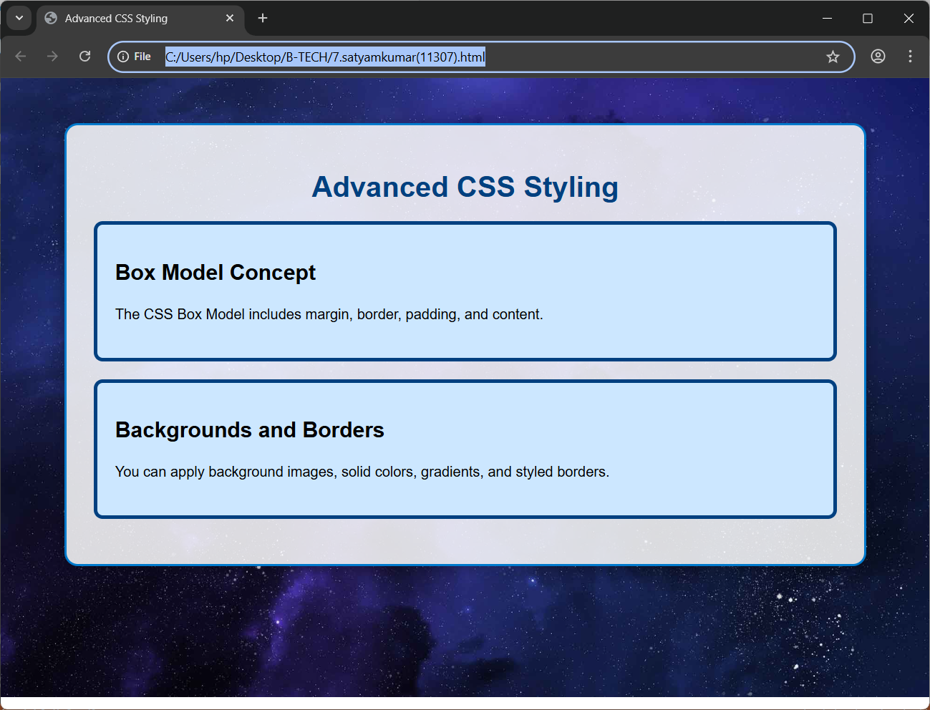

Lab Record- 1.8
Q:- Demonstrate the use of different CSS selectors (class, id, descendant, group, universal).
Code:-
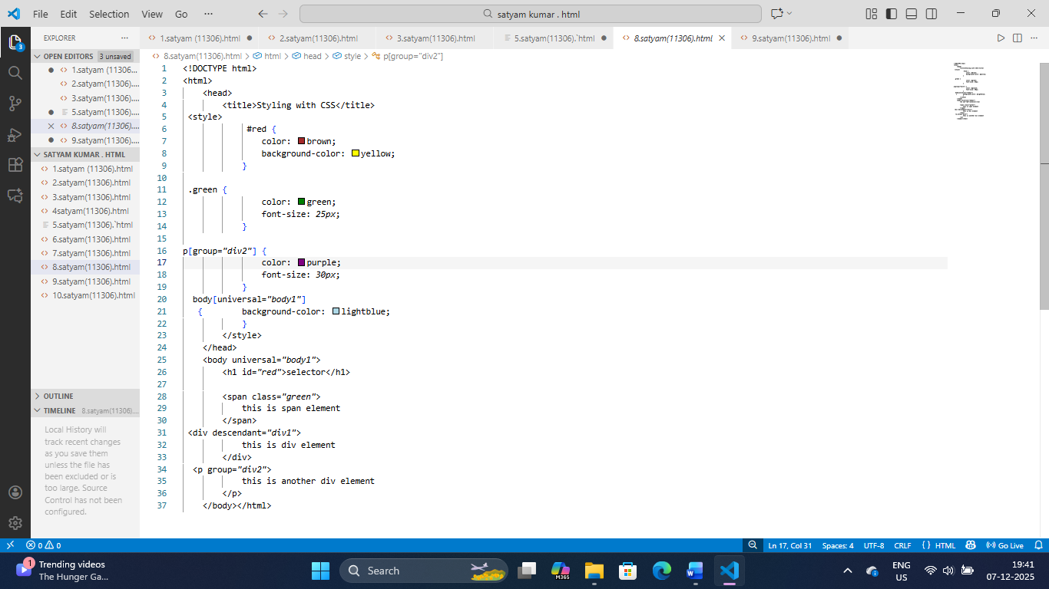

Output:-
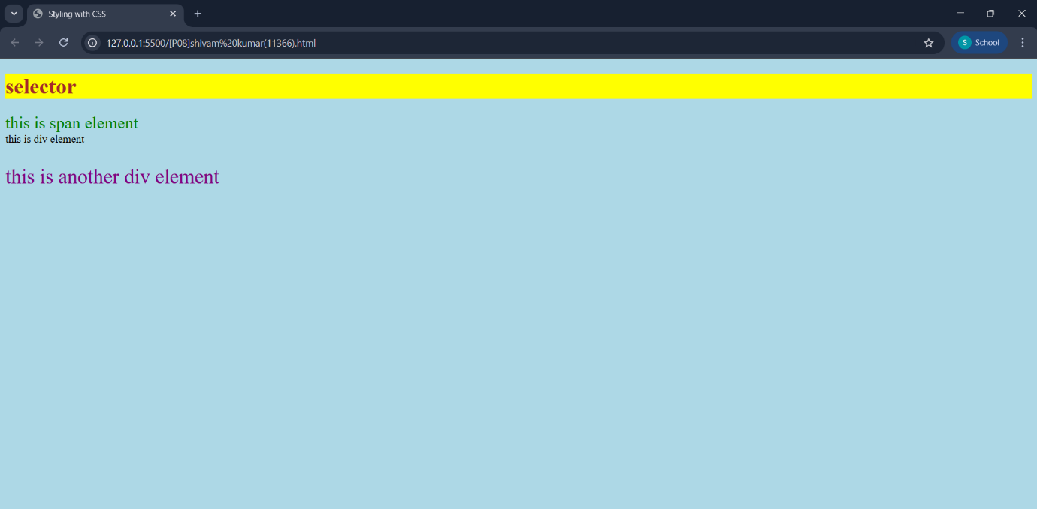

Lab Record- 1.9
Q:- Create a responsive web page using media queries and mobile-first design with flexible units.
Code:-
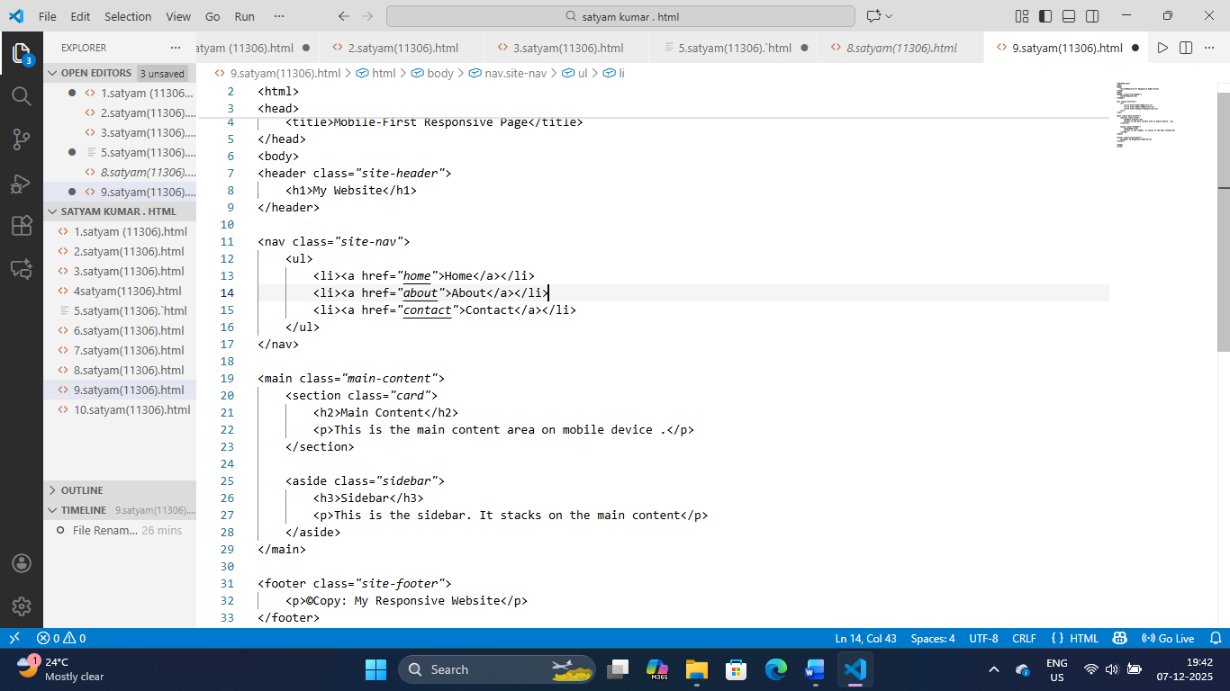

Output:-
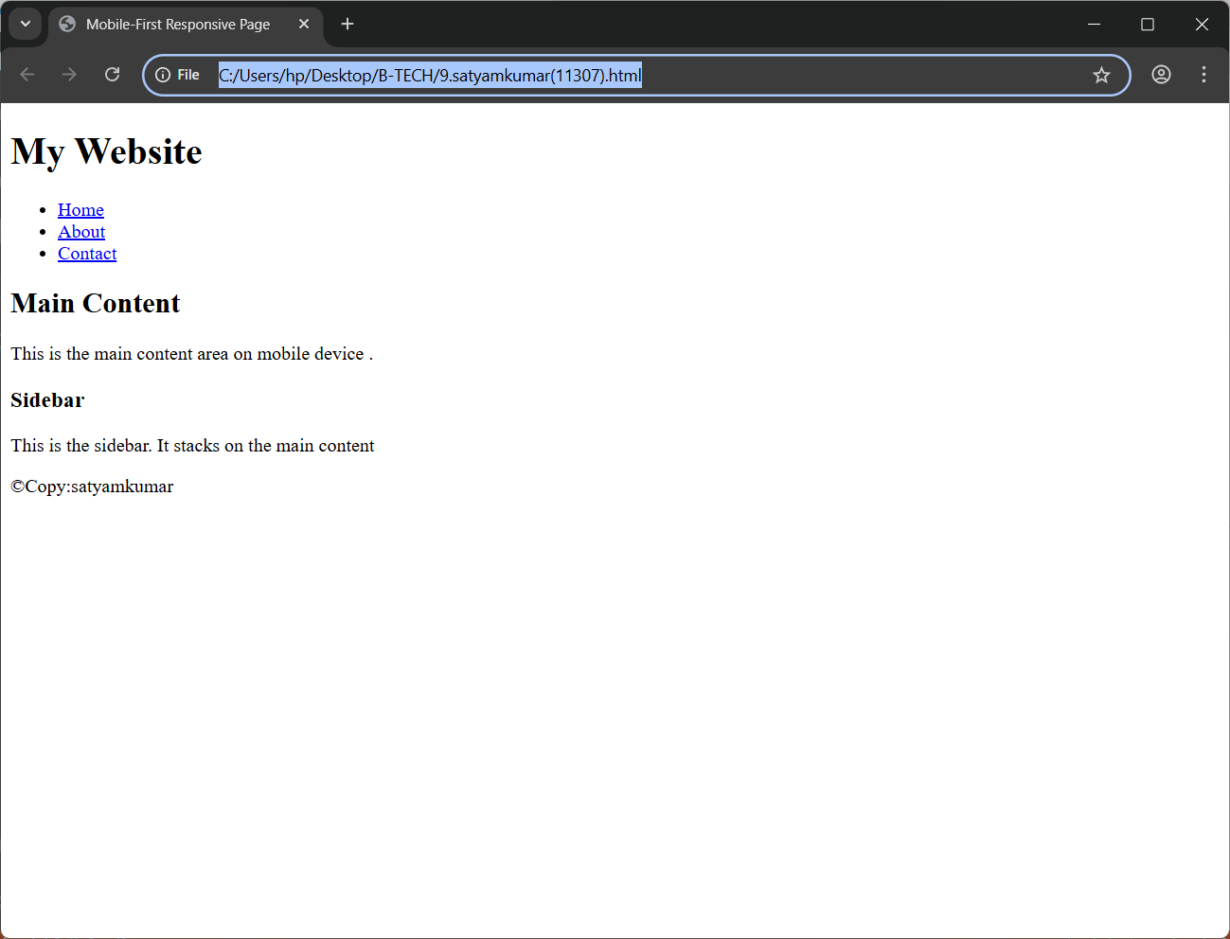
Lab Record- 1.10
Q :- Use div and span elements for layout and apply styling with CSS.
Code:-
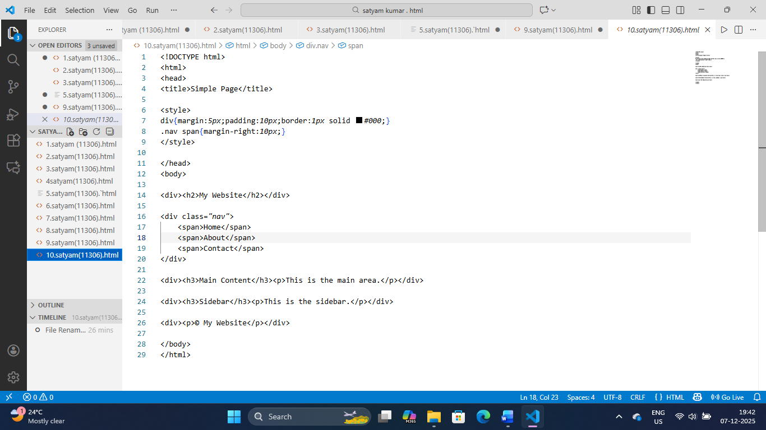
Output:-

